
ITALIAN LIGHT
DOUGLAS R GILBERT

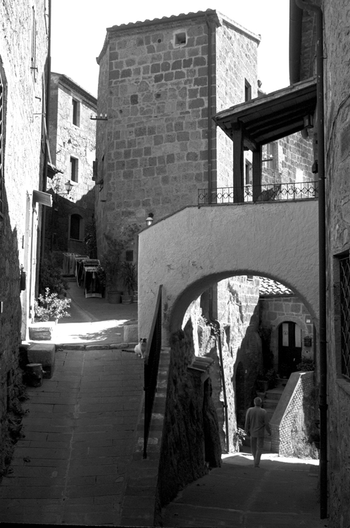
- Sorano, Tuscany. 2007
Silver Gelatin
Edition: 25
Leica M6

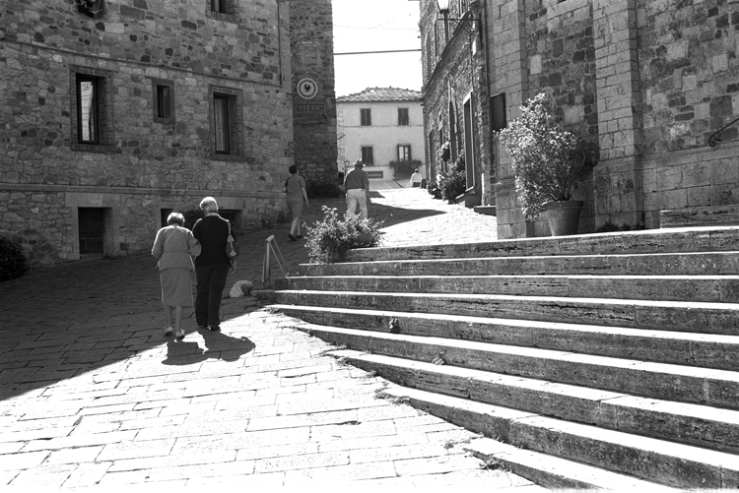
- Castellina in Chianti # 1, Tuscany. 2007
Silver Gelatin
Edition: 25
Leica M6

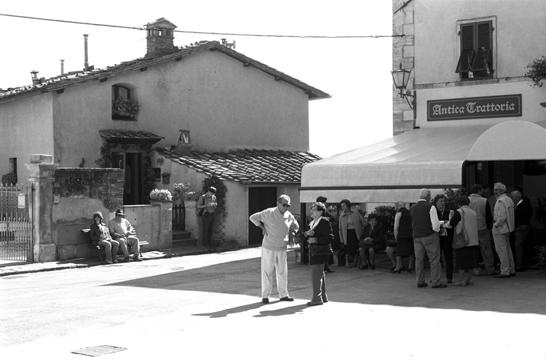
- Castellina in Chianti # 2, Tuscany. 2007
Silver Gelatin
Edition: 25
Leica M6

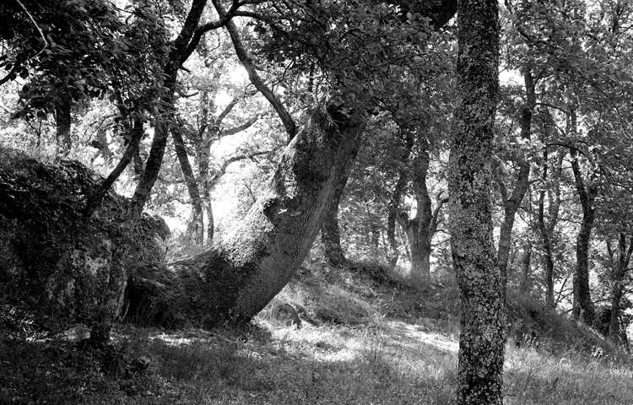
- Etruscan woods, Sorano, Tuscany. 2003
Silver Gelatin
Edition: 25
Leica M6

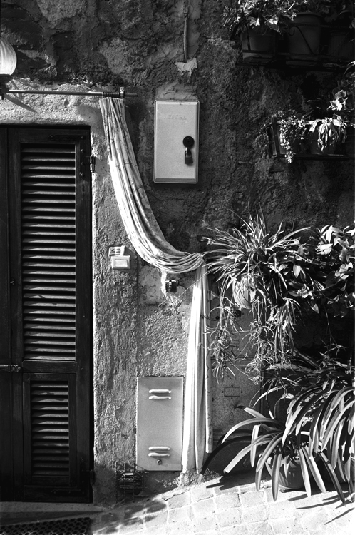
- Doorway, Orvieto, Umbria. 2007
Silver Gelatin
Edition: 25
Leica M6

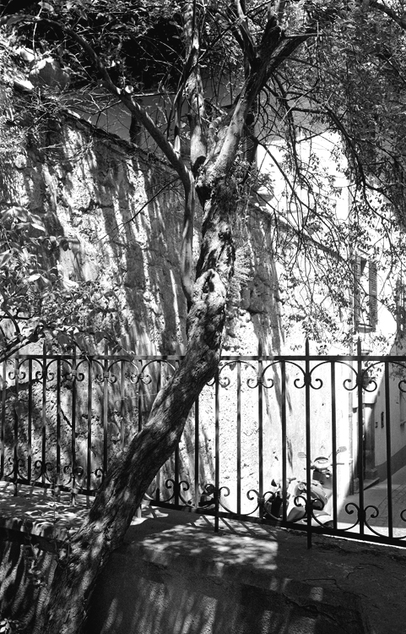
- Shade, Orvieto, Umbria. 2003
Silver Gelatin
Edition: 25
Leica M6
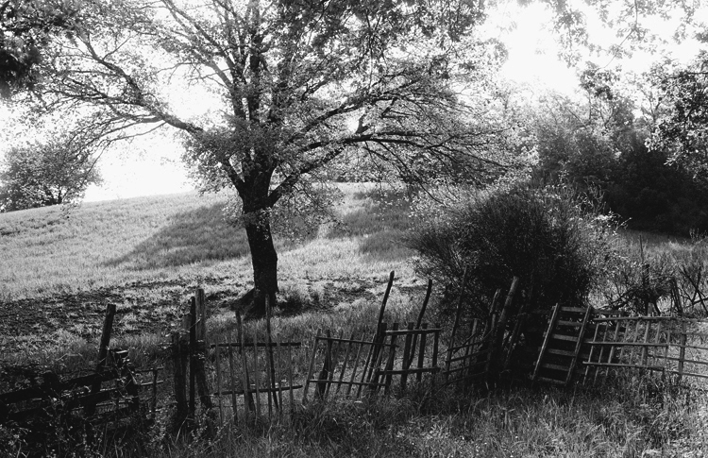
- Near Colonnetta, Umbria. 1999
Silver Gelatin
Edition:1/ 25
Leica M6

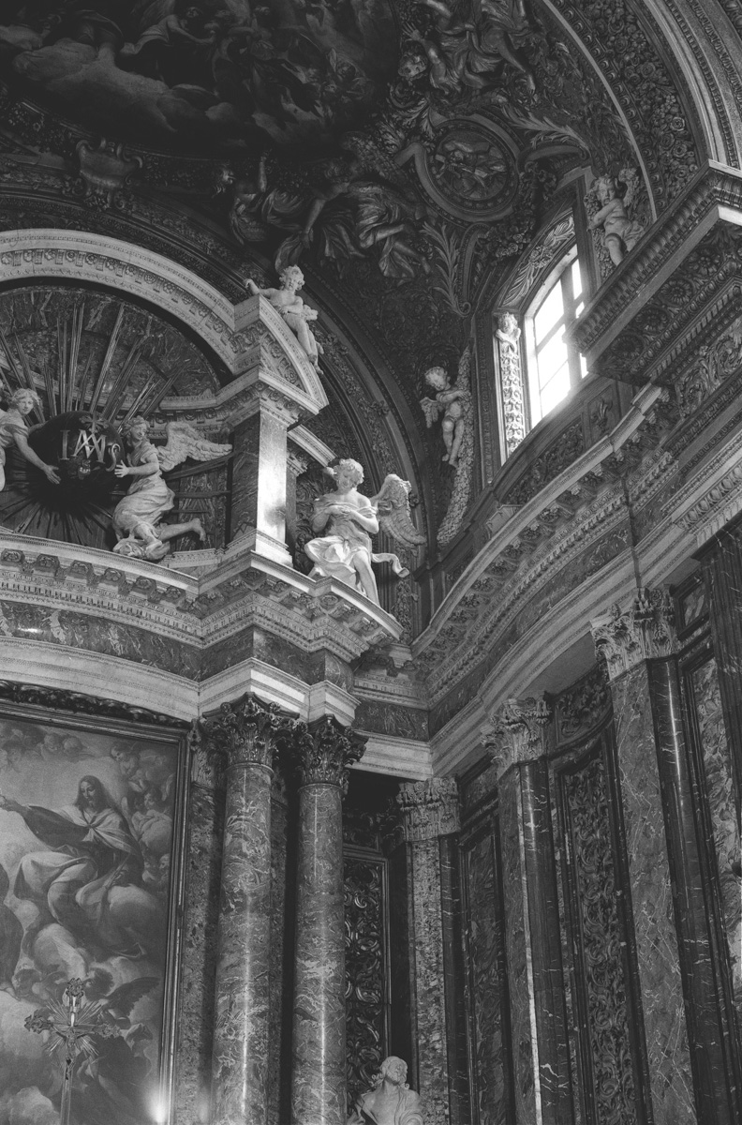
- Chiesa di Gesu e Maria, Rome. 2010
Silver Gelatin
Edition: 25
Leica M6

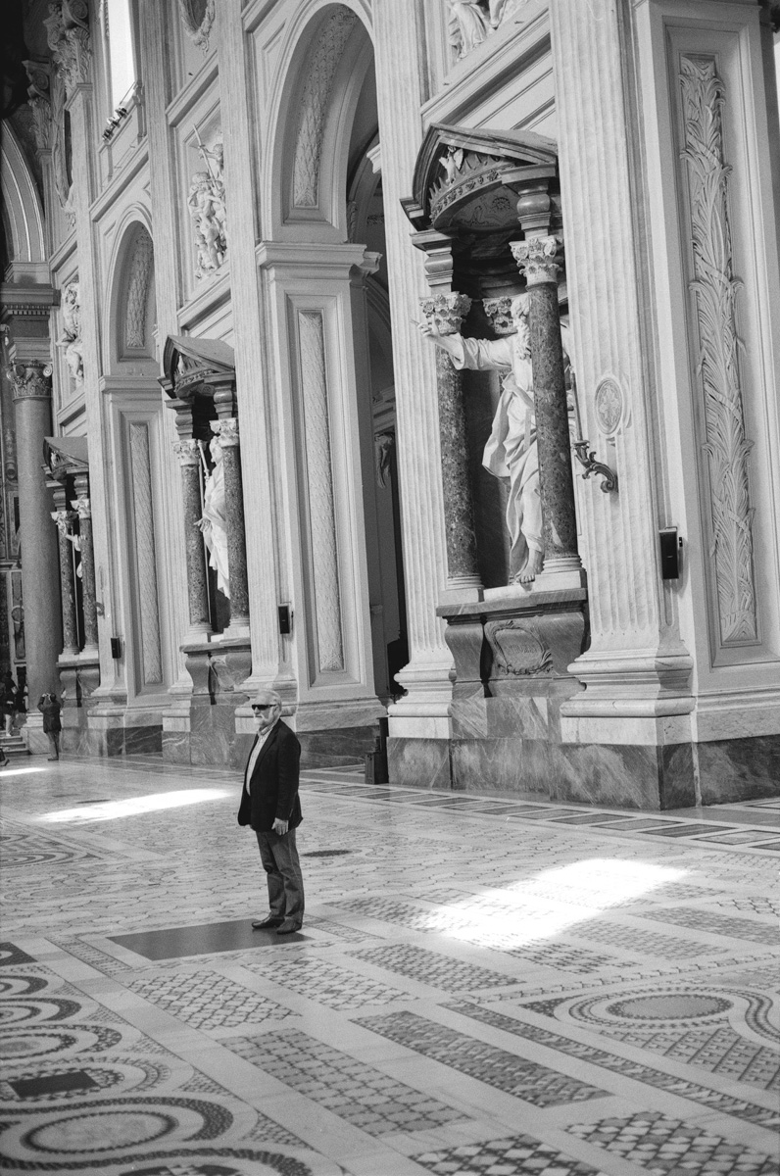
- Basilica of St. John Lateran, 4th C, Rome. 2010
Silver Gelatin
Edition: 25
Leica M6

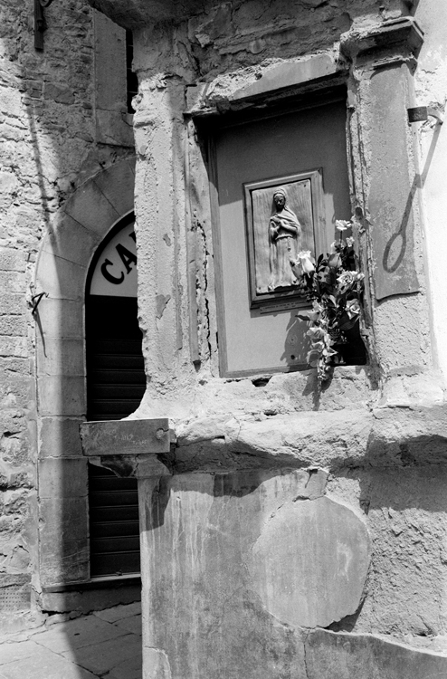
- Shrine niche, Cortona, Tuscany. 1999
Silver Gelatin
Edition:1/ 25
Leica M6

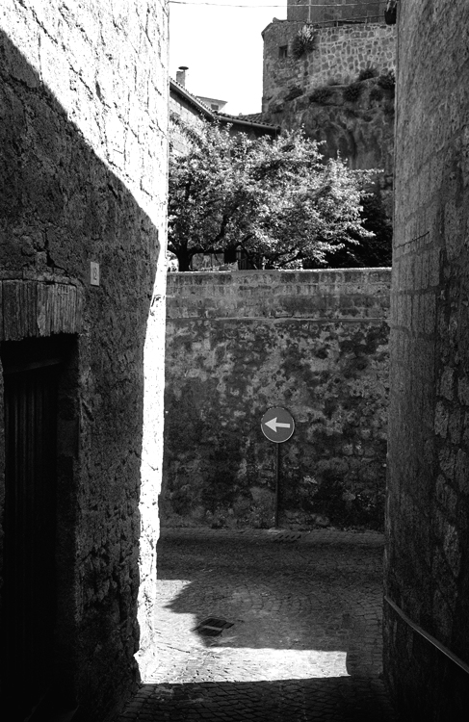
- Intersection, Orvieto, Umbria. 2003
Silver Gelatin
Edition: 25
Leica M6

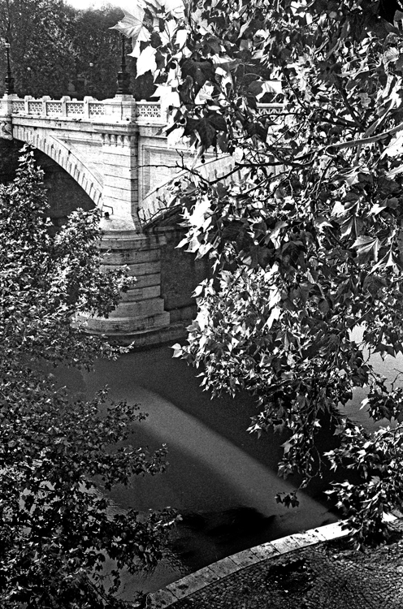
- Tiber River, Rome. 2005
Silver Gelatin
Edition: 25
Leica M6

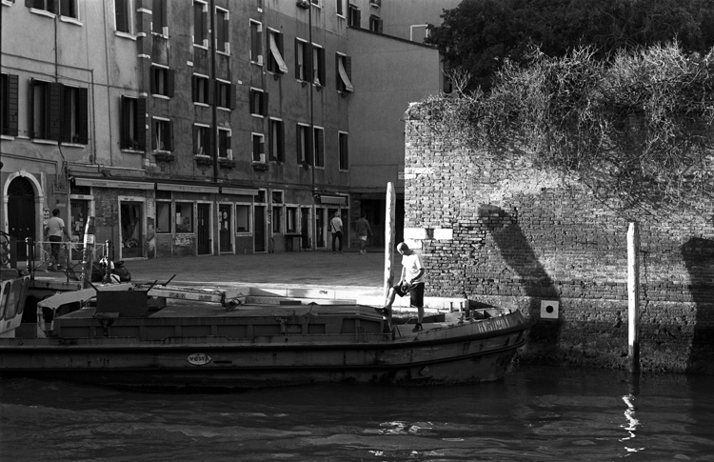
- Rio della Misericordia, District of Cannaregio, Venice. 2007
Silver Gelatin
Edition:1/ 25
Leica M6

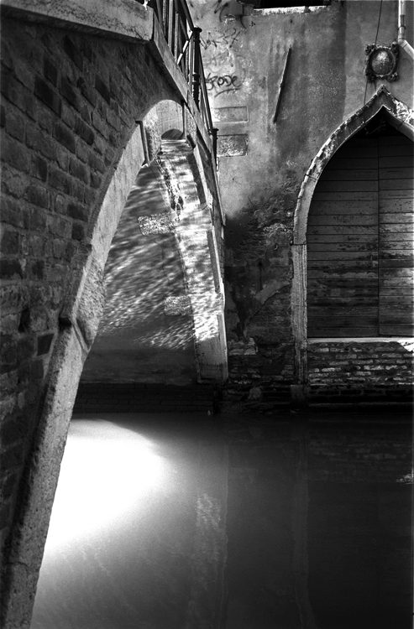
- Bridge, District of Cannaregio, Venice. 2007
Silver Gelatin
Edition: 25
Leica M6

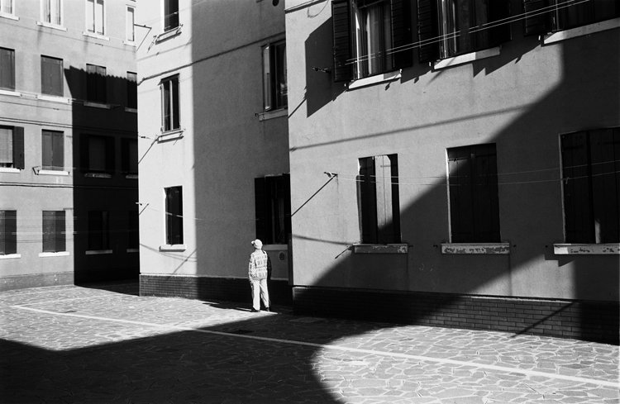
- Housing, District of Cannaregio, Venice. 2007
Silver Gelatin
Edition: 25
Leica M6

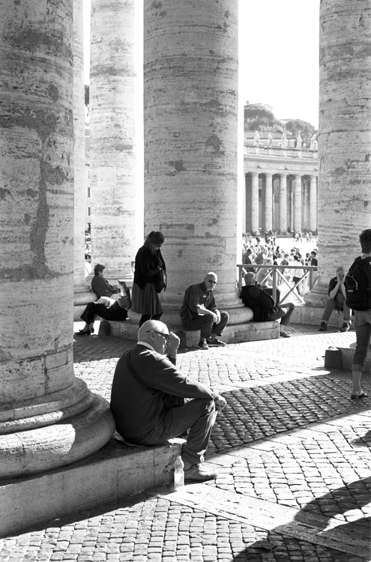
- St Peter’s Square. 2007
Silver Gelatin
Edition: 25
Leica M6

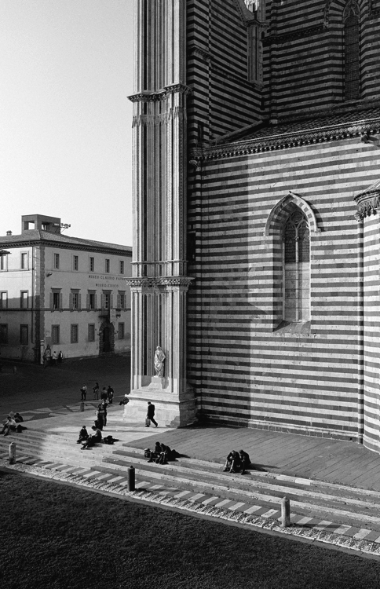
- Duomo di Orvieto, 14 C, Orvieto, Umbria. 1999
Silver Gelatin
Edition:1/ 25
Leica M6
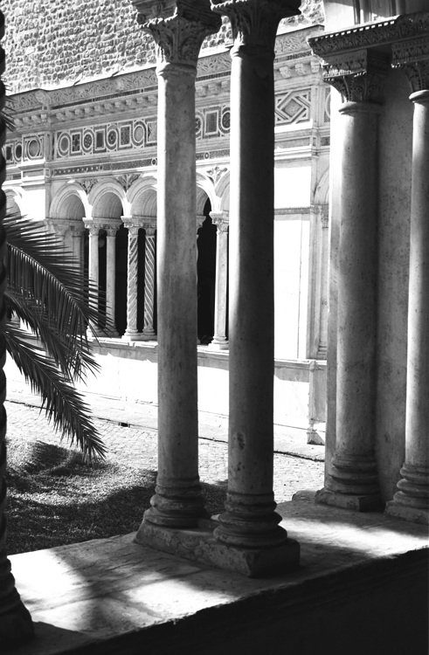
- Cloister of St. John Lateran, 12 C, Rome. 2007
Silver Gelatin
Edition: 25
Leica M6

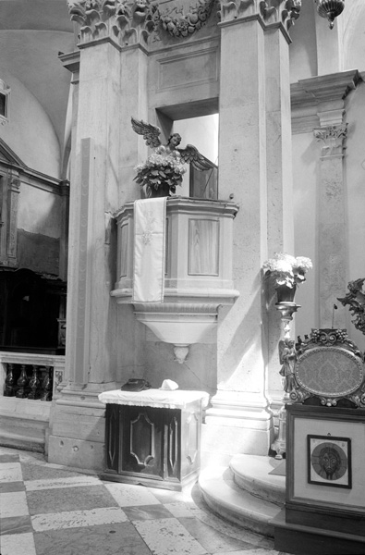
- San Canciano, 9th C, Venice. 2010
Silver Gelatin
Edition: 25
Leica M6

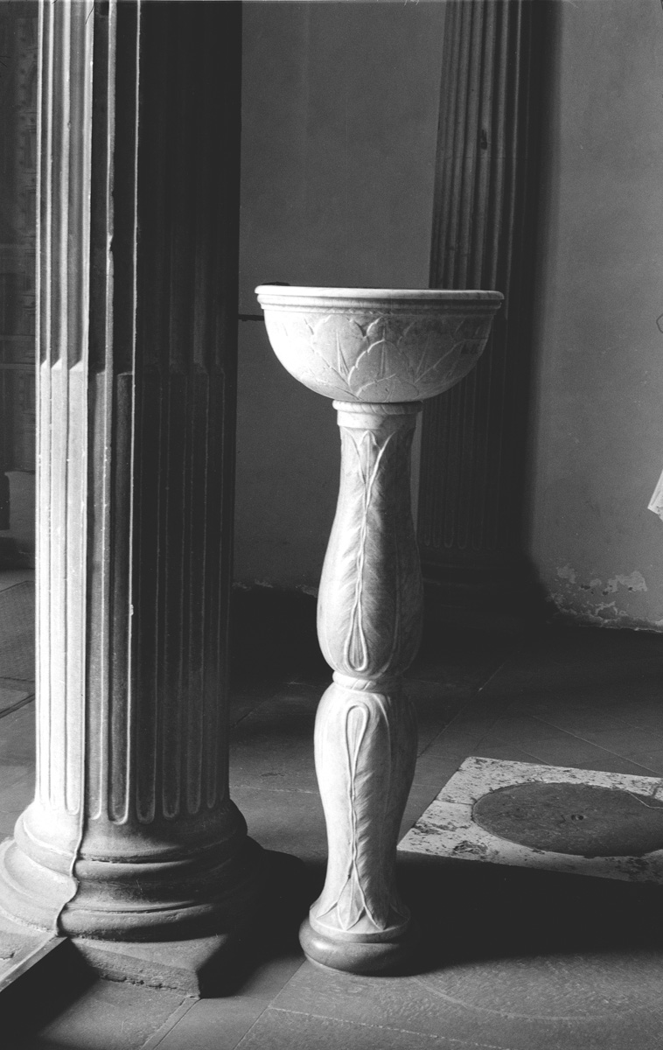
- Water basin, San Augustino, 14 C, Monte San Savino, Tuscany. 2010
Silver Gelatin
Edition:1/ 25
Leica M6

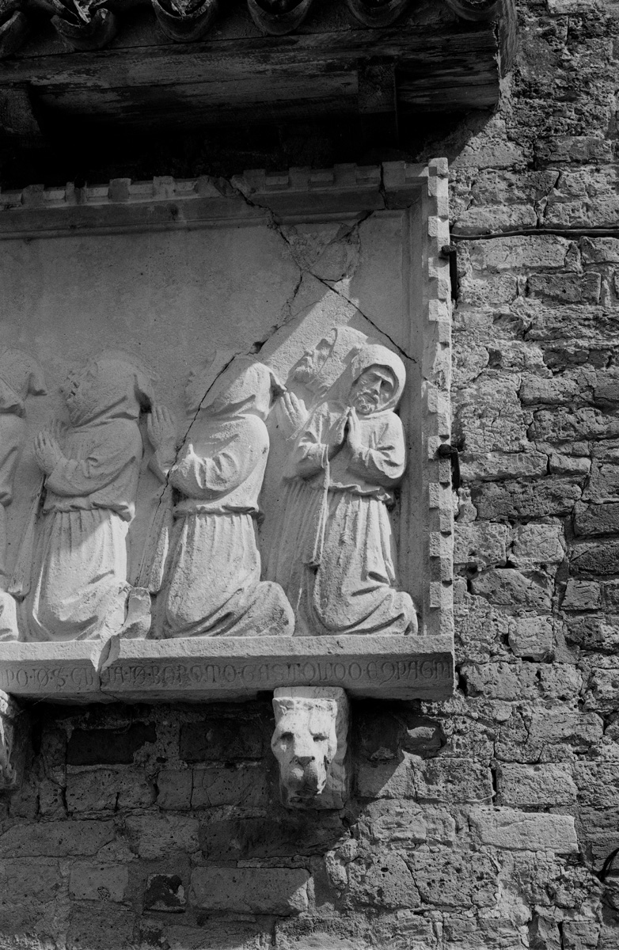
- Exterior wall sculpture, Basilica di Santa Maria Assunta, 7th C, Torcello, Venice. 2007
Silver Gelatin
Edition: 25
Leica M6
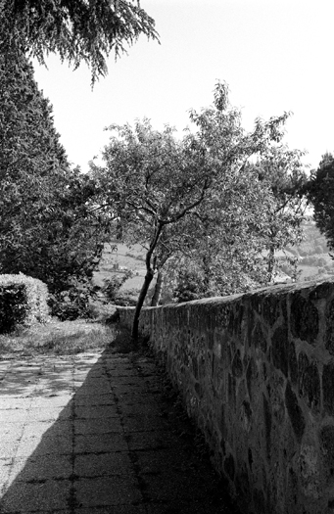
- Tree by wall, Orvieto, Umbria. 2003
Silver Gelatin
Edition: 25
Leica M6

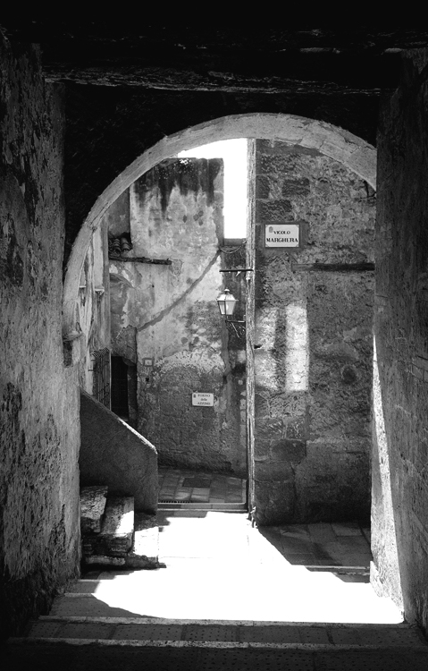
- Walkway, Pitigliano, Tuscany. 2001
Silver Gelatin
Edition:1/ 25
Leica M6
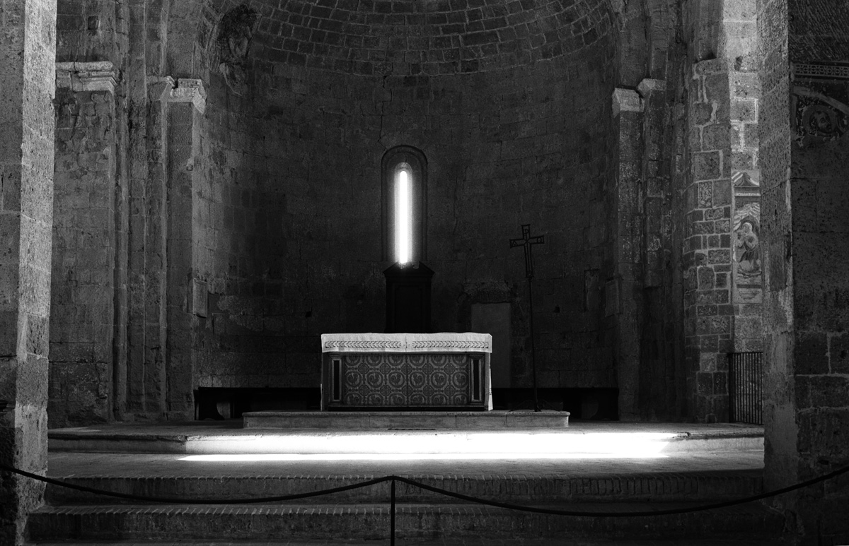
- Duomo di San Pietro e Paolo, 8th C, Sovana, Tuscany. 2007
Silver Gelatin
Edition: 25
Leica M6

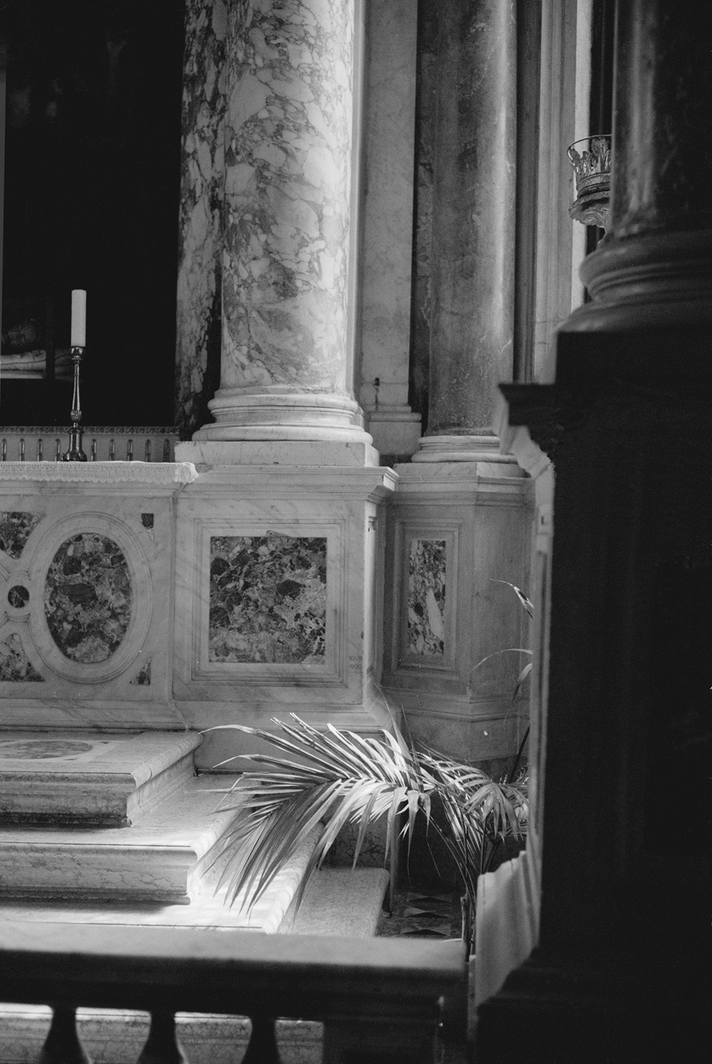
- Side altar and palms, Basilica dei Santi Giovanni e Paolo, 15th C, Venice. 2010
Silver Gelatin
Edition: 25
Leica M6

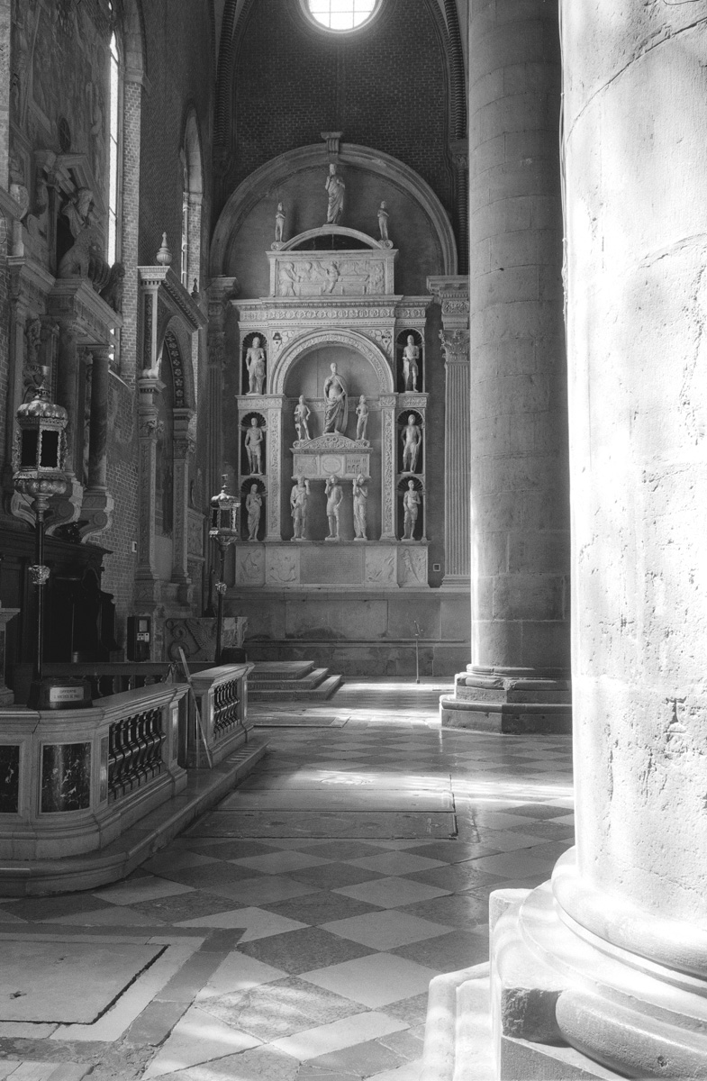
- Side altar and palms, Basilica dei Santi Giovanni e Paolo, 15th C, Venice. 2010
Silver Gelatin
Edition:1/ 25
Leica M6

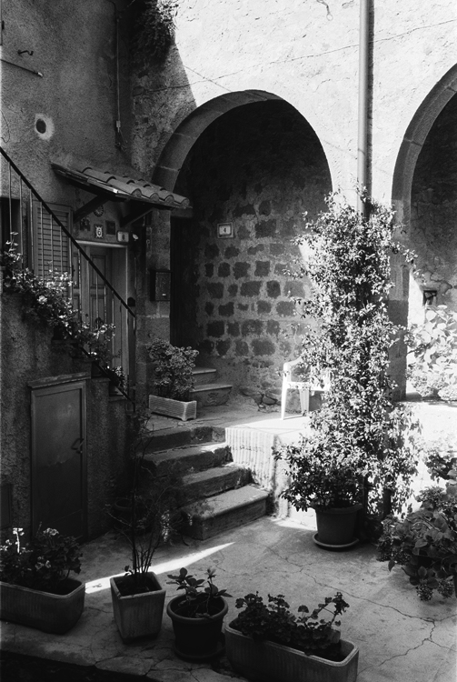
- Private garden in Arcidosso, Tuscany. 2007
Silver Gelatin
Edition: 25
Leica M6
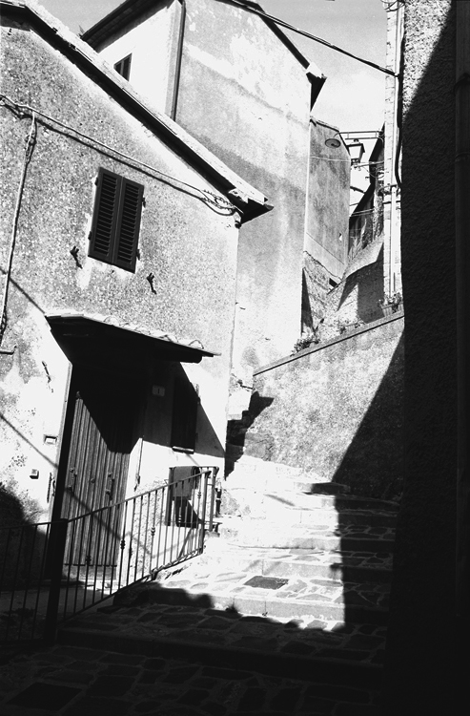
- Neighborhood in Arcidosso, Tuscany. 2007
Silver Gelatin
Edition: 25
Leica M6

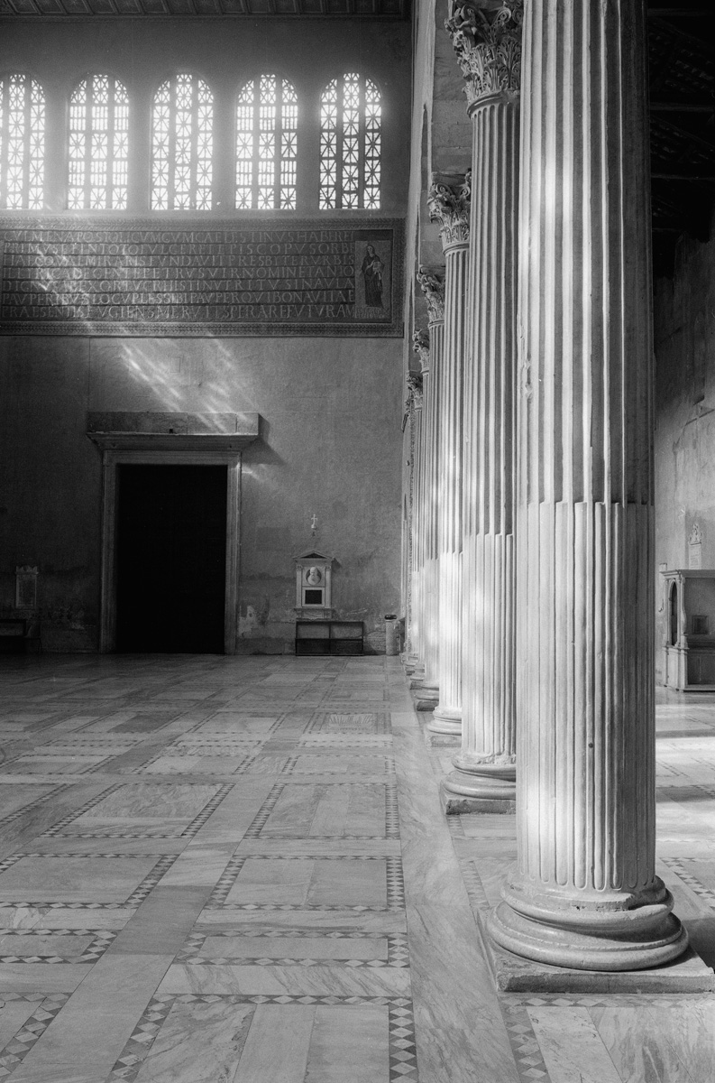
- Santa Sabina, 5th C, Rome. 2010
Silver Gelatin
Edition:1/ 25
Leica M6

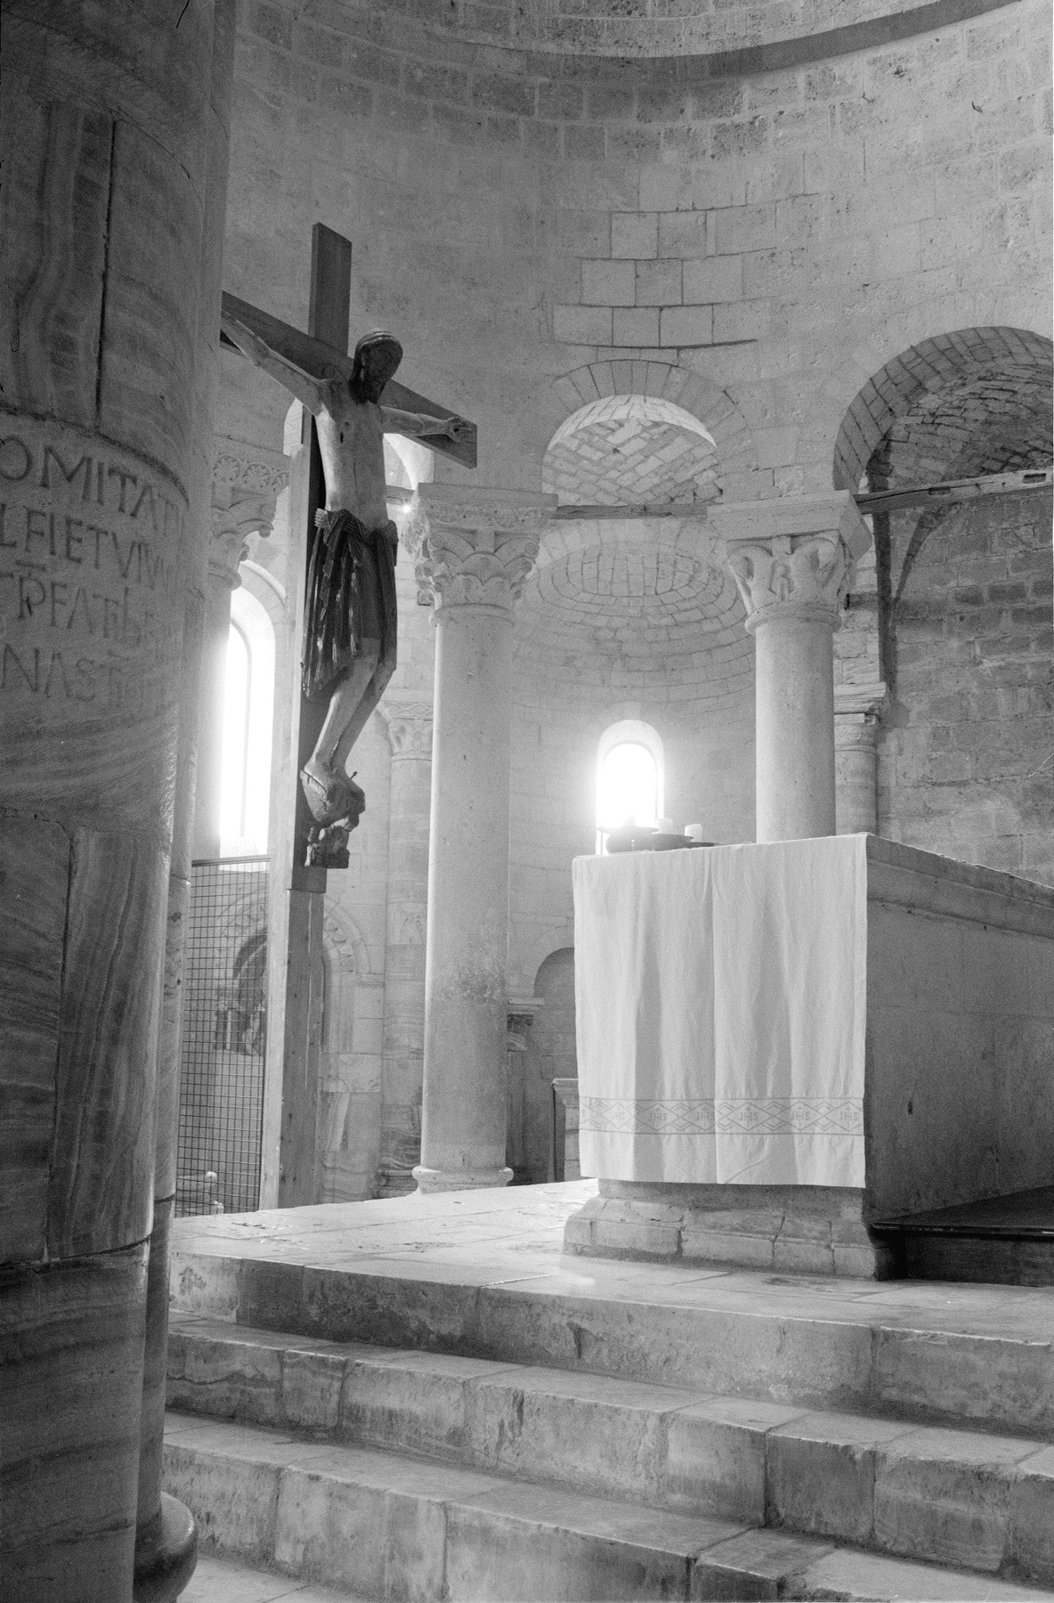
- Abbazio di Sant’Antimo, 12th C, Montalcino, Tuscany. 2010
Silver Gelatin
Edition: 25
Leica M6
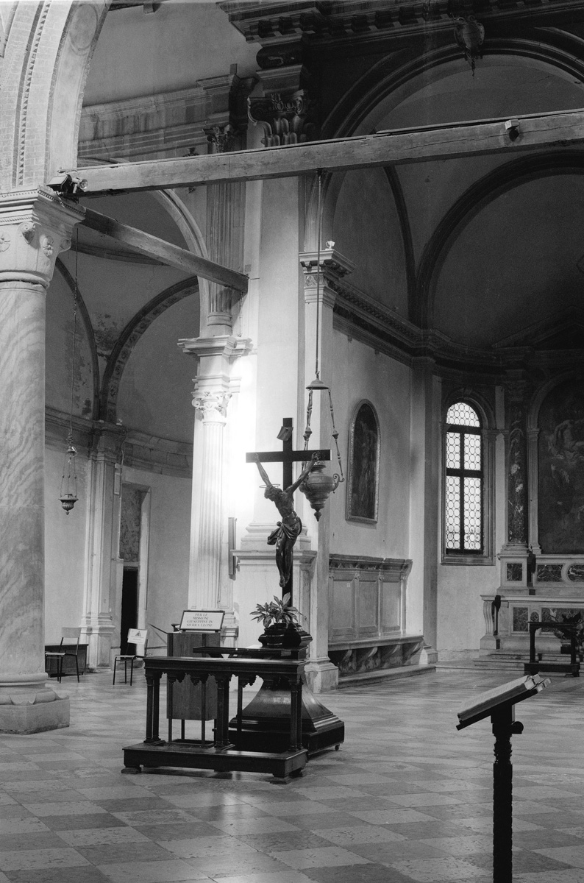
- Cattedrale del Santo Sepolcro, 12th C, Acquapendente, Lazio. 2010
Silver Gelatin
Edition: 25
Leica M6

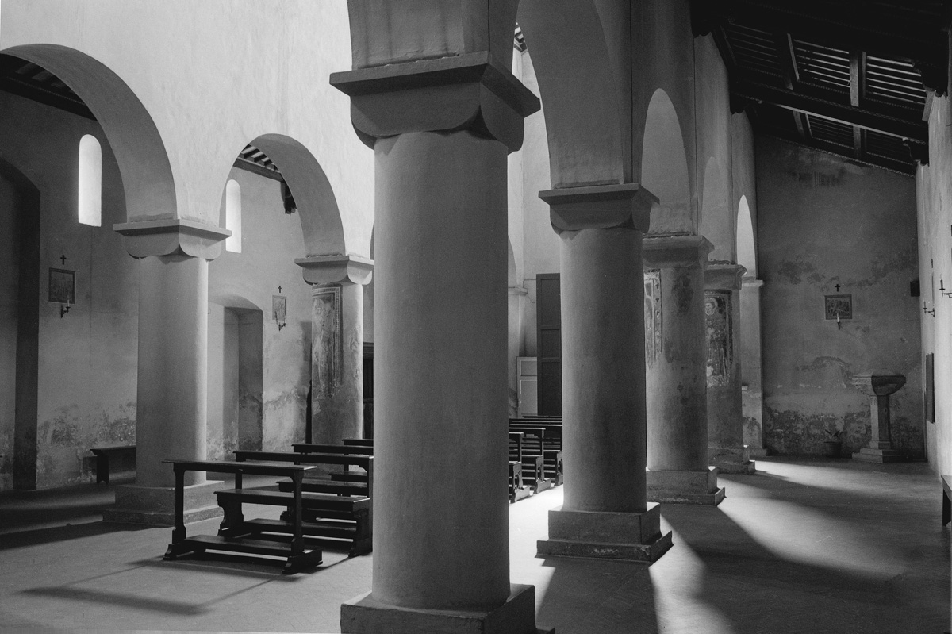
- San Lorenzo de’Arari, 13th C, Orvieto, Umbria. 2010
Silver Gelatin
Edition:1/ 25
Leica M6

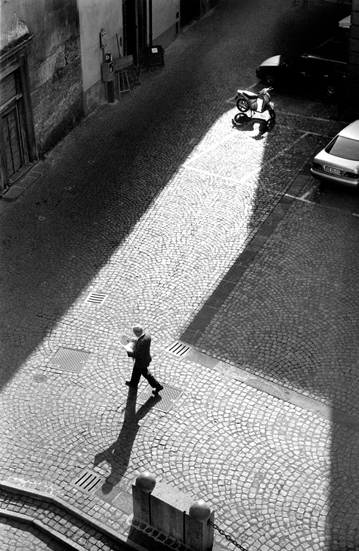
- Piazza del Popolo, Orvieto, Umbria. 1999
Silver Gelatin
Edition: 25
Leica M6

